Exercise: Shell scripts

**1. Write a shell script to get the current date, time, username and current working directory.**

#!/bin/bash

#put current date in $date

date=$(date '+%Y-%m-%d %H:%M:%S')

echo -e "The current date is $date\nThe current user is $USER\nThe current working directory is $PWD"

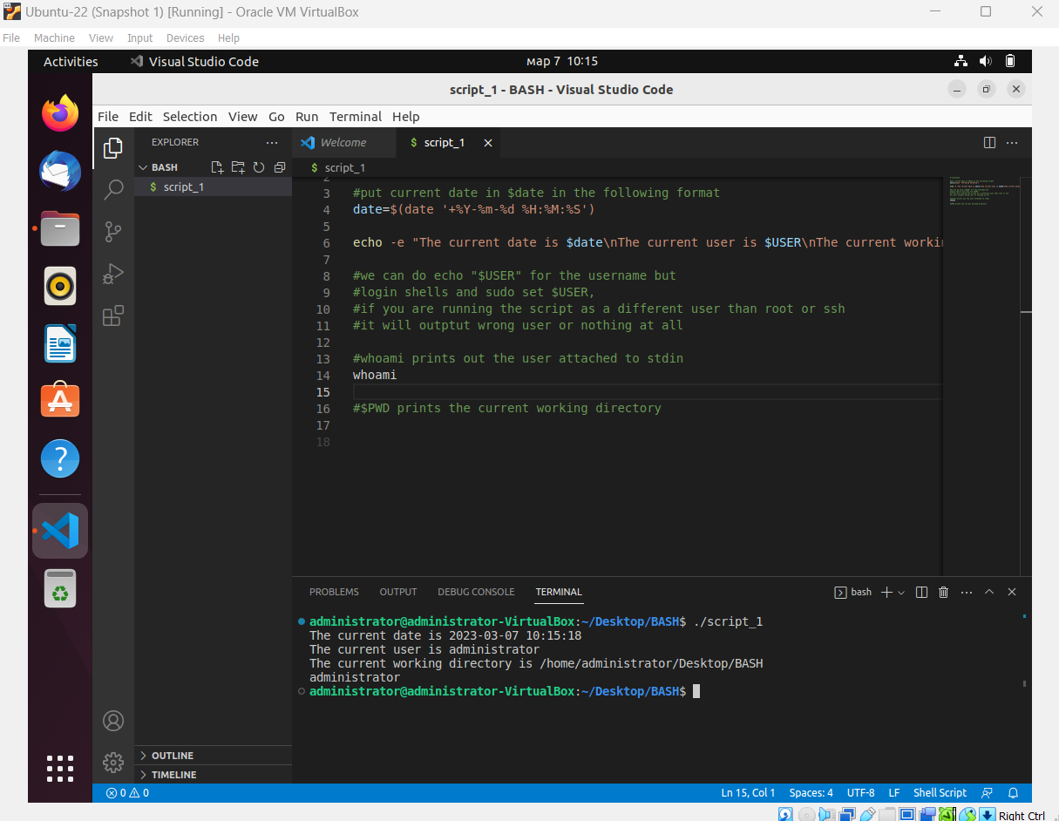

**2. Write a shell script that prints "I love learning about DevOps" on the screen. Message should be a variable.**

#!/bin/bash

text="I love learning about DevOps"

zenity --notification --text="$text"

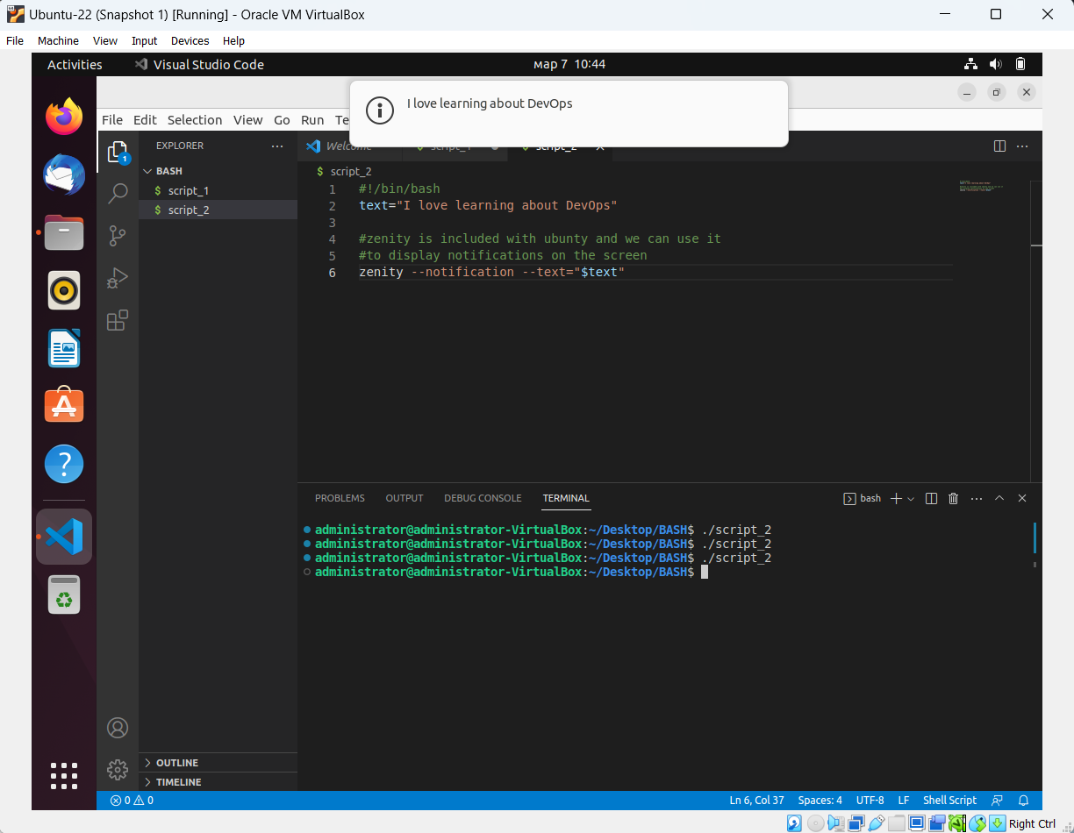

**3. Write a shell script that displays "plan code build test release deploy" on the screen with each appearing on a separate line.**

#!/bin/bash

text=$'plan\ncode\nbuild\ntest\nrelease\ndeploy'

zenity --notification --text="$text"

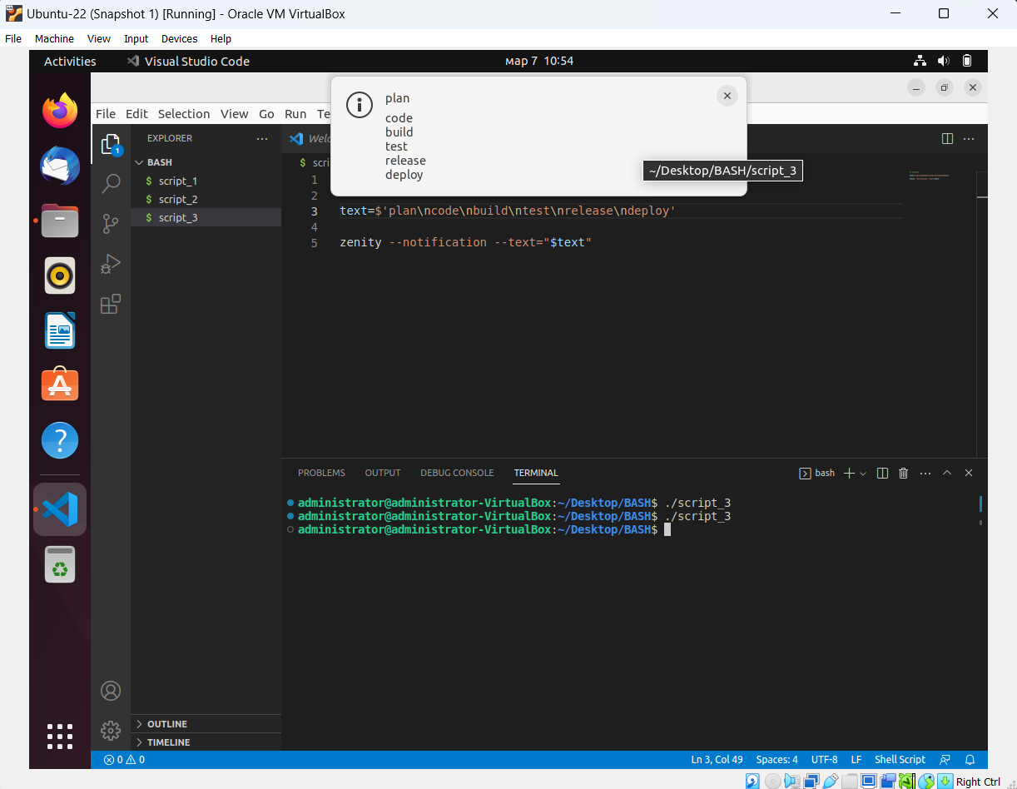

**4. Write a shell script that prompts the user for a name of a file or directory and reports if it is a**

**regular file, a directory, or another type of file. Also perform a ls command against the file or**

**directory with the long listing option.**

#!/bin/bash

ls -l

read -p "Please enter a filename: " filename

if [[ -d "$filename" ]]

then

echo "$filename is a directory"

elif [[ -f "$filename" ]]

then

echo "$filename is a file"

else

echo "$filename is another type of file"

exit 1

fi

**5. Use arguments in a script. Total number of arguments should be three.**

#!/bin/bash

echo "Name of the script: $0"

echo "Total number of arguments: $#"

echo "Values of all the arguments: $@"

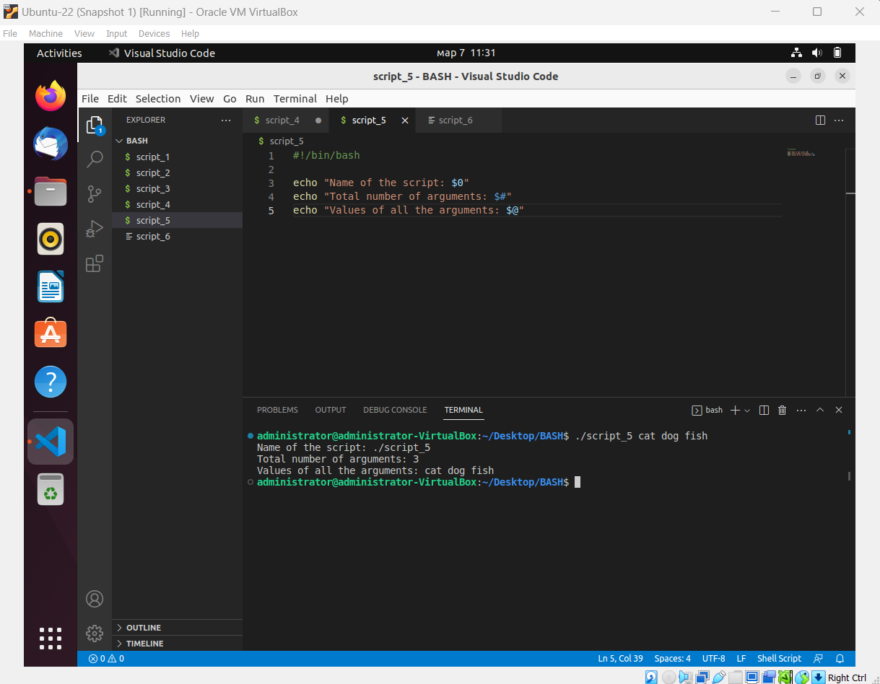

**6. Write a script that will output your name out of a variable and will display the server uptime.**

#!/bin/bash

name="Vlatko"

echo $name

uptime | sed 's/ .*up/The system has been up for/' | sed 's/,.*load/ with a system load/'

